## MINI PROJECT REPORT

**on**

**CBIT STUDENT SERVICE**

**Submitted in partial fulfilment for the completion of**

**B.E., IV Semester**

**INFORMATION TECHNOLOGY**

**By**

**D.BALUCHANDER YADAV (160119737153)**

**BHARGHAV VUPPU (160119737154)**

**Under the guidance of**

**Sri S.Rakesh,**

**Assistant Professor,**

**Dept. of IT, CBIT.**



**DEPARTMENT OF INFORMATION TECHNOLOGY**

**CHAITANYA BHARATHI INSTITUTE OF TECHNOLOGY (A)**

**(Affiliated to Osmania University; Accredited by NBA(AICTE) and NAAC(UGC), ISO Certified 9001:2015)**

**GANDIPET, HYDERABAD – 500 075**

**Website:** [**www.cbit.ac.in**](http://www.cbit.ac.in)

**2021-2022**

**CHAITANYA BHARATHI INSTITUTE OF TECHNOLOGY (A)**

DEPARTMENT OF INFORMATION TECHNOLOGY

**(Affiliated to Osmania University)**

**GANDIPET, HYDERABAD – 500 075**



**CERTIFICATE**

This is to certify that the Mini Project-III entitled “**CBIT STUDENT SERVICE** ” submitted to **CHAITANYA BHARATHI INSTITUTE OF TECHNOLOGY,** in partial fulfilment of the requirements for the completion of B.E., IV semester Information Technology, during the academic year 2019-2020, is a record of original work done by **D.BALU CHANDER YADAV(160119737153),BHARGHAV VUPPU (160119737154)** during the period of study in the Department of IT, CBIT, HYDERABAD, under my supervision and guidance.

**Guide**  **Head of the Department**

**S.Rakesh** [**Dr.K.Radhika**](http://202.65.141.232/?q=node/1603)

Assistant Professor Dept. of IT, Professor, Dept. of IT,

CBIT, Hyderabad. CBIT, Hyderabad.

**CONTENTS**

**Page No.**

**ACKNOWLEDGEMENT** 4

**DECLARATION** 5

**ABSTRACT** 6

**LIST OF FIGURES** 7

1. **INTRODUCTION**
   1. Objective 8
   2. Scope 8
   3. Motivation 8
   4. Problem Statement 8
   5. Over View 9
2. **EXISTING SYSTEM** 11

1. **PROPOSED SYSTEM** 113.1Methodology 12

3.2Architecture of Proposed System 14

1. **SOF****TWARE & HARDWARE REQUIREMENTS** 16
2. **IMPLEMENTATION OF PROJECT** 17
   1. Modules and description 17
   2. Results 17
3. **CONCLUSION & FUTURE SCOPE** 23

**BIBLIOGRAPHY**

**ACKNOWLEDGEMENT**

We are overwhelmed and extremely grateful to have got this wonderful opportunity to work on this phenomenal project through which we have garnered plentiful knowledge and experience.

We would like to express our deep and sincere gratitude to our project guide, **Sri S.Rakesh** for giving us the opportunity to do the project and providing invaluable guidance throughout this project.

We would like to thank the Head of the Department, [**Dr.K.Radhika**](http://202.65.141.232/?q=node/1603), for giving us the opportunity to improve our skills, for his constant support, and for providing us with the sources that are required for the completion of this project.

Our sincere thanks to the Principal**, Prof. G P S Varma**, as well as the management for giving us a good opportunity to improve our skills with a good learning atmosphere.

We are extremely grateful to our parents for their love, prayers, care and sacrifices for educating and preparing us for our future and for supporting us in the completion of this project.

We would like to thank our friends for their constant help and guidance and for their support in completion of the project.

Our thanks to all the members of the staff and to the lab assistants for helping us to carry

out the groundwork of this project and for their timely support.

**DECLARATION**

This is to certify that the work reported in the present report titled “CBIT STUDENT SERVICE” submitted in partial fulfilment for the completion of B.E., VI Semester in the Department of Information Technology, Chaitanya Bharathi Institute of Technology, Hyderabad, is a record of original work,

No part of the report is copied from books / journals / internet and wherever the portion is taken, the same has been duly referred. The reported results are based on the project work done entirely by us and not copied from any other source.

D.BALU CHANDER YADAV (160119737153)

BHARGHAV VUPPU (160119737154)

**ABSTRACT**

Student service application is an online website in which students can clarify any doubt which arise in their mind. It is completely designed website application where questions are asked and answered. With its user-friendly interface students can easily ask any related question which comes to their mind and these questions gets answered if any other student or faculty know the answer. It has the same facilities like Quora but restricts its access to CBIT students.

“Student services” refers to the broad range of supports that community colleges provide to help students navigate through college successfully, including academic counselling and tutoring. Unfortunately, many students do not get the help they need, either because college staff are overburdened or students do not know how to access the services that are available. Here, STUDENT SERVICE APPLICATION makes things easy for students and staff.

MDRC has recently conducted several studies that examine innovative strategies for improving the delivery of student services to community college students. While the research suggests that there should be enhancements that can lead to better use of student services here student service application plays a major role by which students can fully use the student services provided in college.

Software requirements for this application are HTML, CSS, JavaScript, React, Redux, Fire Base.

**LIST OF FIGURES**

|  |  |  |
| --- | --- | --- |
| **Figure** | **Description** | **Page No.** |
| Fig. 5.1 | Home page | 18 |
| Fig. 5.2 | Login page | 18 |
| Fig. 5.3 | Register page | 19 |
| Fig. 5.4 | Show password | 19 |
| Fig. 5.5 | Hide password | 20 |
| Fig. 5.6 | Main page | 20 |
| Fig. 5.7 | Post-1 | 21 |
| Fig. 5.8 | Post-2 | 21 |
| Fig. 5.9 | Post-3 | 22 |
|  |  |  |

1. **INTRODUCTION**

**1.1 Objective**

The student service is a web application, developed for making students clear their doubts in a easy way. This application provides the facilities of asking question and answering to a question. It also provides an easy interaction between the staff and students. Mainly aimed to produce a web-based system that make things happen easily for students while clarifying their doubts. The application must be user-friendly. Simply to use whenever doubt arises in student mind.

**1.2 Scope**

The scope of this project is to produce a web-based application that clarifies the doubt arise in students mind which has become a hectic task during this pandemic. This project traverses a lot of areas ranging from business, hospitals, colleges, government sector etc, and required to perform several researches to be able to achieve the project objectives. React and Firebase used for the development of the application etc.

**1.3 Motivation**

As we know that many questions arise in students mind but there are less chances to get them answered. If the students are freshers then they face a lot of problems in search of answers to their questions. To overcome this problem we came through an idea of making a CBIT STUDENT SERVICE application which helps student to ask questions and also answer the other questions. The application is linked with firebase which stores all the questions and answers.

Keeping this in mind we came with the solution and developed this project. The web application CBIT STUDENT SERVICE is mainly aimed to produce a user-friendly interface. To ease the student tasks whenever they come up with a doubt.

**1.4 Problem Statement**

A CBIT STUDENT SERVICE is a web application which has facilities like Quora but restricts to CBIT users. In which students and staff can post stuff related to academics. It’s main goal is to clarify student doubts which relate to academics or non-academics.

Many students face problems while searching answers to their questions where this user-friendly application make things happen easy for them.

**1.5 Overview**

CBIT STUDENT SERIVE is a web application built to make things easy when ever a question arises in student mind. This can be used instead of college notice board where students and staff rush to view it, rushing towards notice boards is no more because of this use-friendly web application, where notices can be viewed from their mobile or laptop.

**HTML**

**HTML** (Hyper Text Mark-up Language) is the most basic building block of the Web. It defines the meaning and structure of web content. Other technologies besides HTML are generally used to describe a web page's appearance/presentation.

"Hypertext" refers to links that connect web pages to one another, either within a single website or between websites. Links are a fundamental aspect of the Web. By uploading content to the Internet and linking it to pages created by other people, you become an active participant in the World Wide Web. HTML markup includes special “elements” such as  [<head>](https://developer.mozilla.org/en-US/docs/Web/HTML/Element/head), [<title>](https://developer.mozilla.org/en-US/docs/Web/HTML/Element/title), [<body>](https://developer.mozilla.org/en-US/docs/Web/HTML/Element/body), [<header>](https://developer.mozilla.org/en-US/docs/Web/HTML/Element/header), [<footer>](https://developer.mozilla.org/en-US/docs/Web/HTML/Element/footer), [<article>](https://developer.mozilla.org/en-US/docs/Web/HTML/Element/article), [<section>](https://developer.mozilla.org/en-US/docs/Web/HTML/Element/section), [<p>](https://developer.mozilla.org/en-US/docs/Web/HTML/Element/p), [<div>](https://developer.mozilla.org/en-US/docs/Web/HTML/Element/div), [<span>](https://developer.mozilla.org/en-US/docs/Web/HTML/Element/span), [<img>](https://developer.mozilla.org/en-US/docs/Web/HTML/Element/img), [<nav>](https://developer.mozilla.org/en-US/docs/Web/HTML/Element/nav), [<output>](https://developer.mozilla.org/en-US/docs/Web/HTML/Element/output), [<progress>](https://developer.mozilla.org/en-US/docs/Web/HTML/Element/progress), [<video>](https://developer.mozilla.org/en-US/docs/Web/HTML/Element/video), [<ul>](https://developer.mozilla.org/en-US/docs/Web/HTML/Element/ul), [<ol>](https://developer.mozilla.org/en-US/docs/Web/HTML/Element/ol), [<li>](https://developer.mozilla.org/en-US/docs/Web/HTML/Element/li) and many others.

An HTML element is set off from other text in a document by "tags", which consist of the element name surrounded by "<" and ">".  The name of an element inside a tag is case insensitive. That is, it can be written in uppercase, lowercase, or a mixture. For example, the <title> tag can be written as <Title>, <TITLE>, or in any other way.

**CSS**

**CSS** (**C**ascading **S**tyle **S**heets) is a simply designed language intended to simplify the process of making web pages presentable. CSS allows you to apply styles to web pages. More importantly, CSS enables you to do this independent of the HTML that makes up each web page.  
CSS is easy to learn and understood but it provides powerful control over the presentation of an HTML document. A CSS comprises of style rules that are interpreted by the browser and then applied to the corresponding elements in your document.  
A style rule set consists of a selector and declaration block.

**JAVASCRIPT**

JavaScript often abbreviated as JS, is a programming language that conforms to the ECMAScript specification.[9] JavaScript is high-level, often just-in-time compiled, and multi-paradigm. It has curly-bracket syntax, dynamic typing, prototype-based object-orientation, and first-class functions.

As a multi-paradigm language, JavaScript supports event-driven, functional, and imperative programming styles. It has application programming interfaces (APIs) for working with text, dates, regular expressions, standard data structures, and the Document Object Model (DOM).

JavaScript engines were originally used only in web browsers, but they are now core components of other software systems, most notably servers and a variety of applications.

Although there are similarities between JavaScript and Java, including language name, syntax, and respective standard libraries, the two languages are distinct and differ greatly in design

**REACT**

React (also known as React.js or ReactJS) is an open-source front-end JavaScript library for building user interfaces or UI components. It is maintained by Facebook and a community of individual developers and companies. However, React is only concerned with state management and rendering that state to the DOM, so creating React applications usually requires the use of additional libraries for routing, as well as certain client-side functionality.

React code is made of entities called components. Components can be rendered to a particular element in the DOM using the React DOM library. When rendering a component, one can pass in values that are known as "props".

Another notable feature is the use of a virtual Document Object Model, or virtual DOM. React creates an in-memory data-structure cache, computes the resulting differences, and then updates the browser's displayed DOM efficiently.

**FIREBASE**

Firebase is a platform developed by Google for creating mobile and web applications. It was originally an independent company founded in 2011.

In 2014, Google acquired the platform and it is now their flagship offering for app development. Firebase evolved from Envolve, a prior startup founded by James Tamplin and Andrew Lee in 2011. Envolve provided developers an API that enables the integration of online chat functionality into their websites. After releasing the chat service, Tamplin and Lee found that it was being used to pass application data that were not chat messages. Tamplin and Lee decided to separate the chat system and the real-time architecture that powered it. They founded Firebase as a separate company in September 2011 and it launched to the public in April 2012.

**2. EXISTING SYSTEM**

In the existing system, students have to directly contact staff to get their questions answered. It is available only in college hours.

The main drawback of this is students need to meet the staff manually which is a time waste process. Also, in this pandemic time meeting manually is not possible.

**Disadvantages of existing System:**

1. Students should manually meet staff in search of answers to their questions.
2. If the staff fails in answering student should look up for other staff.
3. Its time taking process.
4. Staff aren’t available 24/7.

**3. PROPOSED SYSTEM**

In the Proposed System, we are going to introduce CBIT STUDENT SERVICE web application which replaces the existing system.

Students can post their questions in the website by registering through username email avatar and password. If someone answer their question they can view the answer by clicking on their question and the answers are displayed below the question. It also has the information of the student or staff who answered the question and when they answered it.

**Advantages of Proposed System:**

1. It helps the students to post their questions and get them answered.
2. At pandemic time many administration faculty were busy with their work and couldn’t answer the calls and failed answering the questions of students and parents.
3. There are many chances for student in getting their questions answered.
4. The Application is very user-friendly, can be used by anyone with an internet access from anywhere.
5. Available 24/7.
6. Manual interaction is not required.

**3.1 Methodology**

This project consists of the following modules:

1. **AUTHENTICATION:** If user has already registered then he can login through login page and if a user is new to this they can register through Register page .While logging in if the user credentials are valid the user gets logged into home page where they can access the application facilities.

2. **MAIN PAGE:** After successful authentication user get directed to main page where the application facilities are provided. Here they can post their question or check the answers for their posted question. Users can also view the answers of other user questions and can also give answer to others questions. For a question the following details are available:

A. Timestamp of answer.

B. Users username who answered the question.

C. Email and Avatar of the user who posted the question

**Functional Requirements:**

Requirement analysis is a software engineering technique that is composed of the various tasks that determine the needs or conditions that are to be met for a new or altered product, taking into consideration the possible conflicting requirements of the various users.

Functional requirements are those requirements that are used to illustrate the internal working nature of the system, the description of the system, and explanation of each subsystem. It consists of what task the system should perform, the processes involved, which data should the system holds and the interfaces with the user.

The functional requirements identified are:

* 1. User's registration: The system should allow new users to register online.
  2. Automatic update to database once a question is posted: Whenever there's new question posted by user the system should be able update the database without any additional efforts from the user.
  3. Automatic update to database when answer is given: Whenever a user gives answer to a question system should be able update the database without any additional efforts from the user.
  4. Auto-Generated Page: After database gets updated the user has to see the redirected new page which shows the current questions and answers.

**Non-Functional Requirements:**

It describes aspects of the system that are concerned with how the system provides the functional requirements. They are:

* 1. Security: The subsystem should provide a high level of security and integrity of the data held by the system, only authorized staff of college can gain access to the application and only users with valid password and username can login to view user's page.
  2. Performance and Response time: The system should have high performance rate when executing user's input and should be able to provide feedback or response within a short time span usually 50 seconds for highly complicated task and 20 to 25 seconds for less complicated task.
  3. Availability: This system should always be available for access at 24 hours, 7 days a week. Also, in the occurrence of any major system malfunctioning, the system should be available in 1 to 2 working days, so that the business process is not severely affected.
  4. Ease of use: Considered the level of knowledge possessed by the users of this system, a simple but quality user interface should be developed to make it easy to understand and required less training.

**3.2 Architecture Of Proposed System**

The user needs to follow the following steps:

* In the login page: The user has to enter the credentials and click login.
* In the register page: The user has to enter the username email password and avatar link to create an account and click register.
* As you are logged in, you are directed to main page where you can access all the functionalities of application.
* Now the user can post their question by clicking add question in nav bar.
* Users can view the answers to their questions in below posts section.
* Users can also add answers to a question in post section by clicking add answer button beside a question.
* Avatar of the user can be viewed in navbar.
* After the user task gets finished they can logout by clicking on logout button on navbar.

**Use Case Diagram**

**4. SOFTWARE AND HARDWARE REQUIREMENTS**

**Software Requirements:**

* Operating System Windows OS above 7
* User Interface HTML, CSS
* Client-side Scripting JavaScript
* Web Technologies React,Redux
* Database Firebase Firestore
* Deployed in Heroku
* Other Applications VS Code

**Hardware Requirements:**

**1.Development Environment**

|  |  |
| --- | --- |
| Processor | Intel(R) Core (TM) i7-8700 CPU @ 3.20GHz 3.19 GHz |
| RAM | 4 GB(Min) |
| Disk Space | 10 GB or more |

**2.Application Environment**

Any device with windows O.S and Internet Access

**5. IMPLEMENTATION OF PROJECT**

System implementation is used to bring a developed system or sub system into operational use and turning it over to the user. It involves programmer users and operational management. In this project, there are different stages – planning, design, coding and testing. The objective is to completely finish each logical step in the development process before moving onto the next. Modifications can be made if necessary.

**5.1 MODULES AND DESCRIPTION**

**Authentication module:**

**1.Registration**

* User Registration

**2.Login**

* User logs in using login credentials.

**3.Posting question**

* User posts their question in post section by clicking add question.

**4.Answering posted question**

* User can add answer to other users question by clicking add answer button in post section.

**5.Viewing posted questions and answers**

* User can view the answer given by other users to their question by clicking on their question in post section.

**5.2 RESULTS**

With the successful implementation of all the different stages of the project, we have developed an enhanced, automated, accurate, user-friendly CBIT STUDENT SERVICE APPLICATION for students.

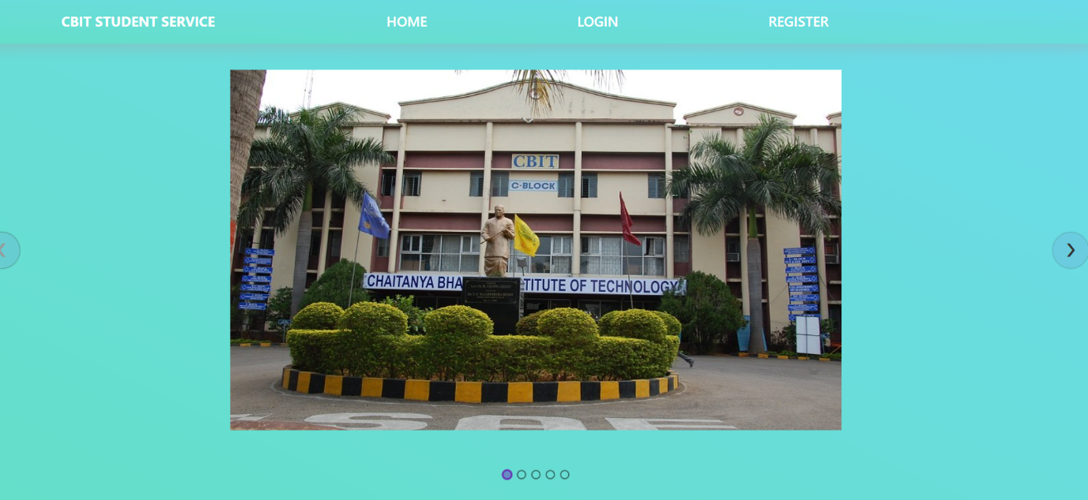

Fig. 5.1

In home page we can find carousel of CBIT institute pics.

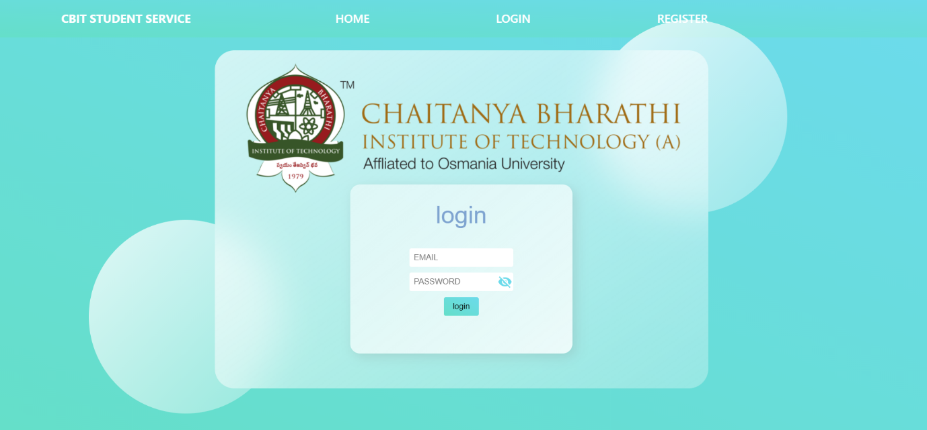

Fig. 5.2

In login page user enters their credentials and gets logged in

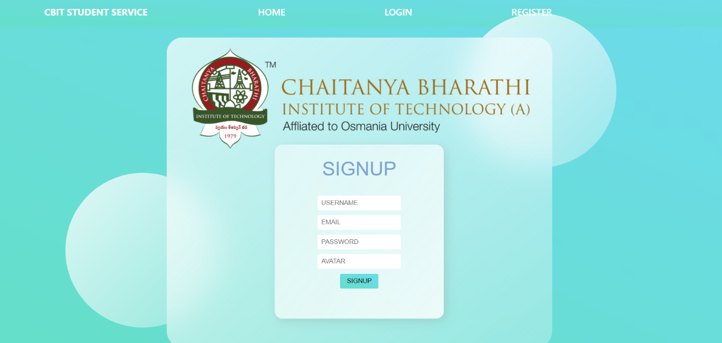

Fig. 5.3

Register page allows user to create account using username ,email, password and avatar.

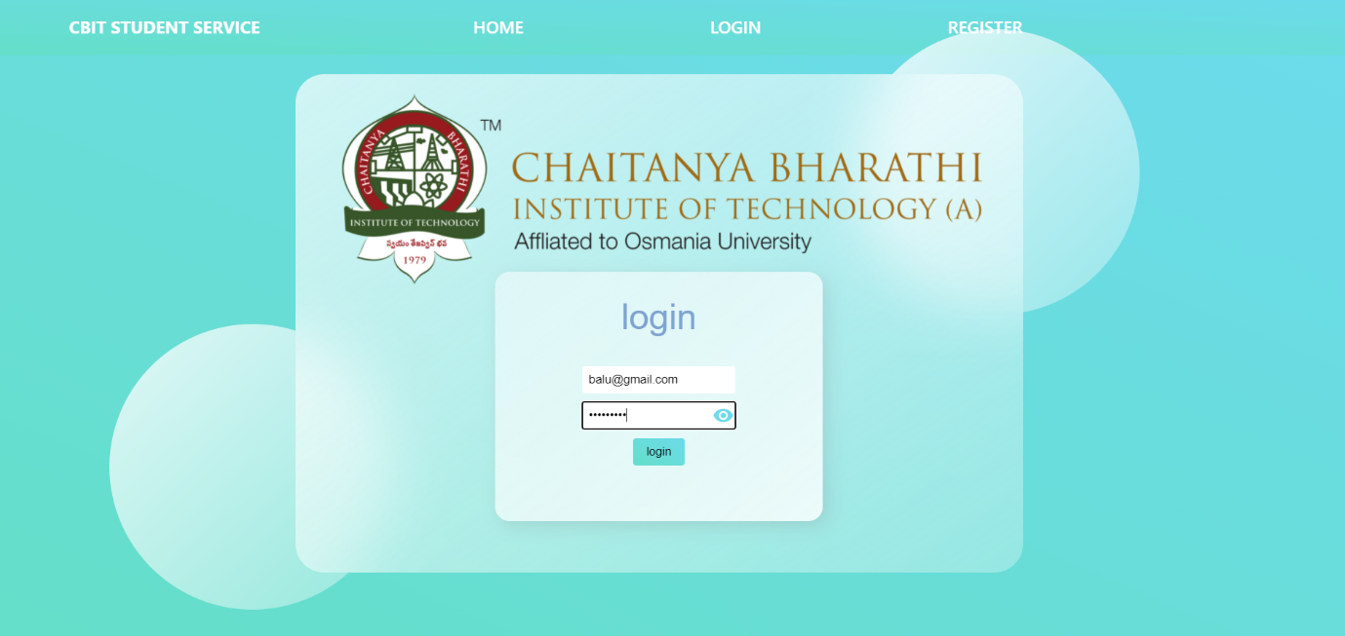

Fig. 5.4

Here we can see that the password is not visible as the visibility icon is turned on.

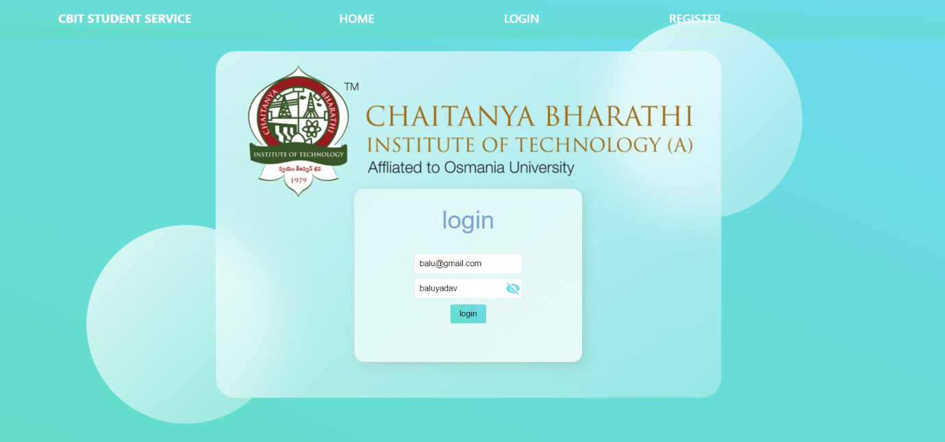

Fig. 5.5

Here we can see that the password is visible as the visibility icon is turned off.

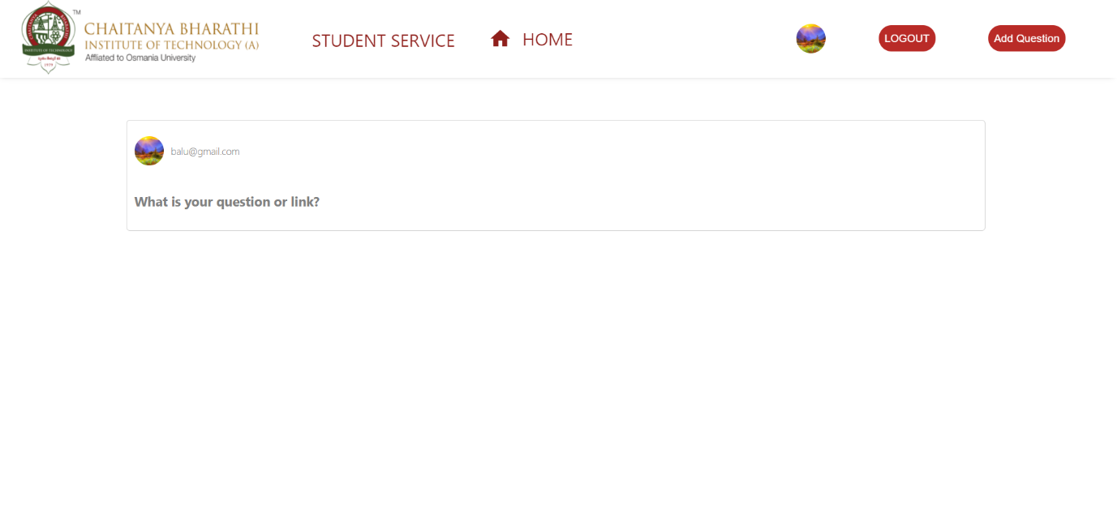

Fig. 5.6

In main page we have nav bar and posts section with logout and add question buttons.

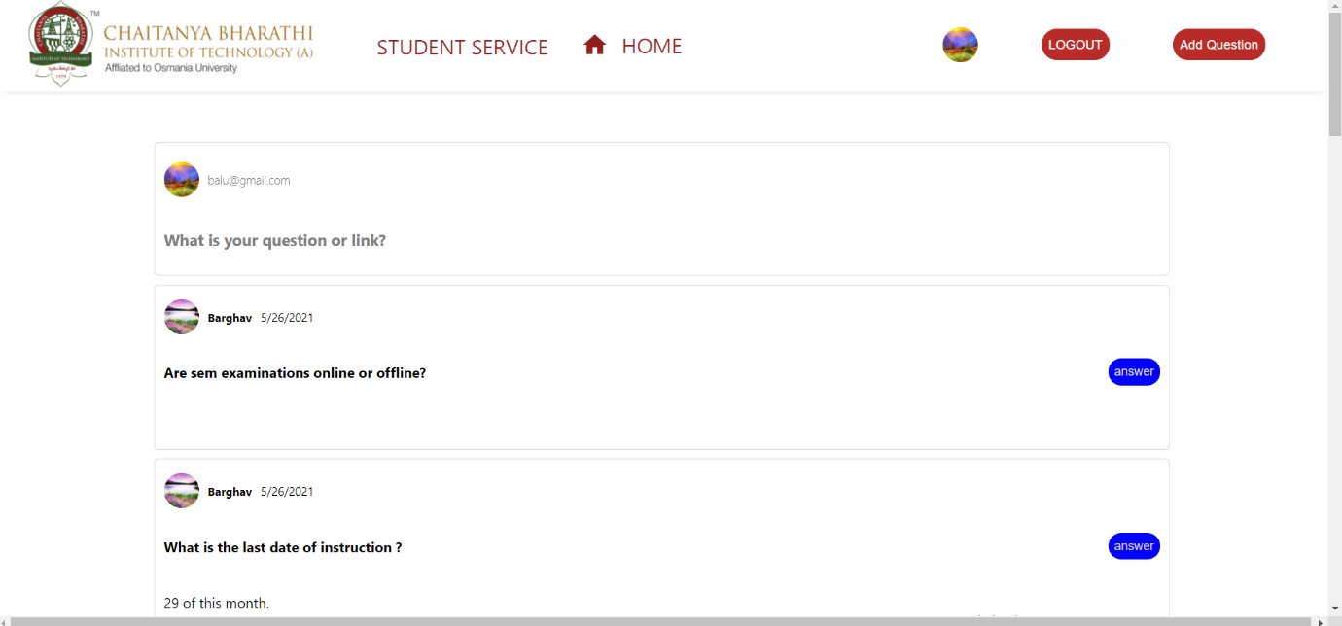

Fig. 5.7

This is post section where related stuff and questions are posted

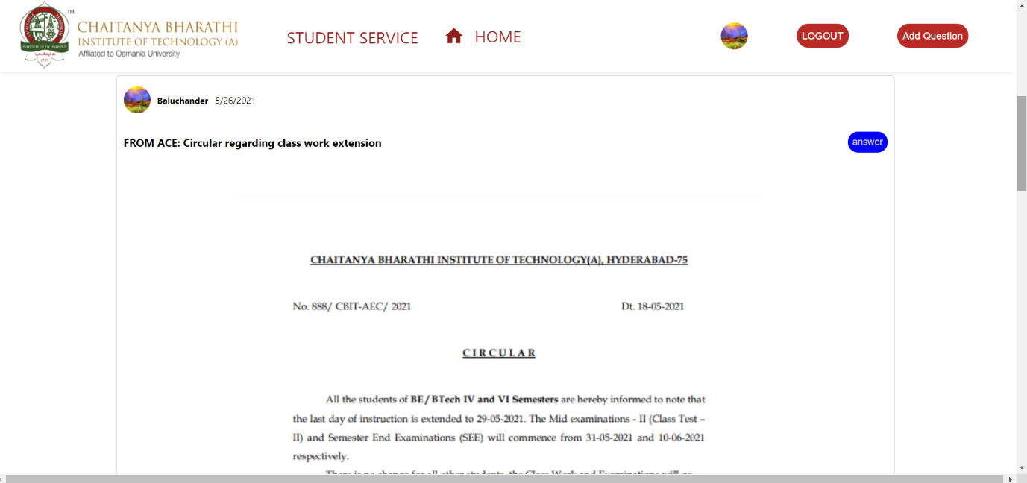

Fig. 5.8

Post :Circular regarding class work extension

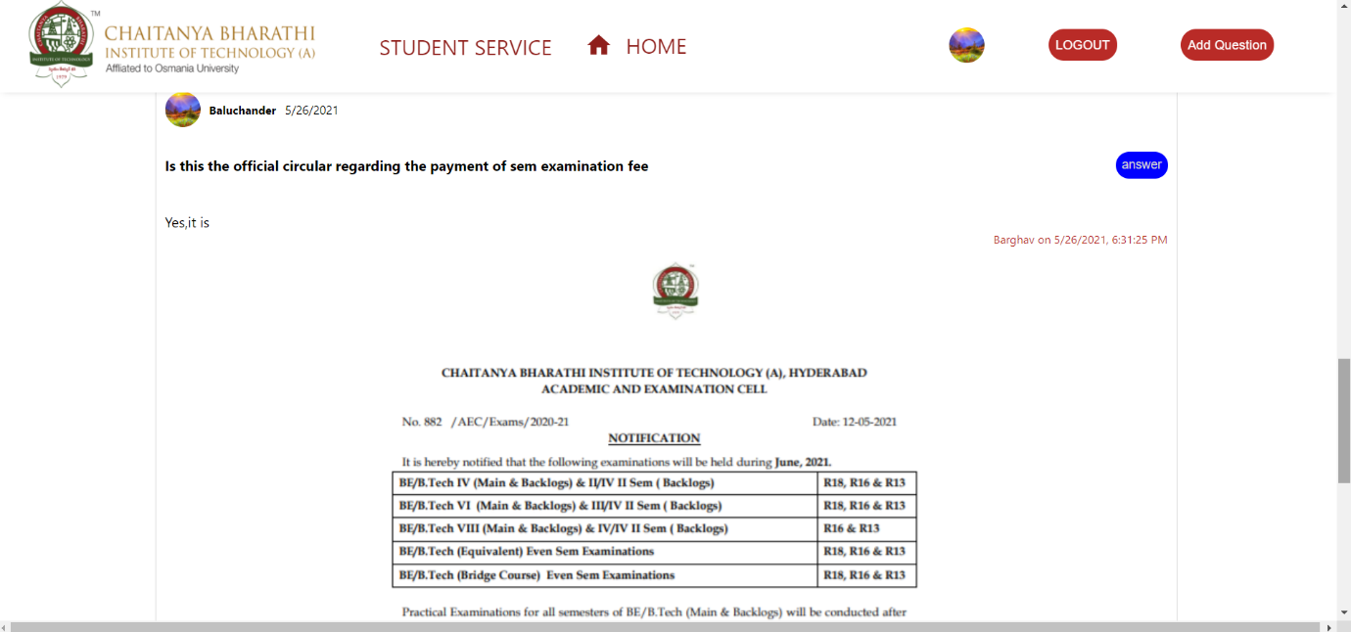

Fig. 5.9

Post :Circular regarding payment of sem examination fee.

**6.CONCLUSION & FUTURE SCOPE**

The web application CBIT STUDENT SRVICE is very helpful for every student which make things happen very easy while searching answers to their questions. Users can add answers to other user questions and also view the answers to other questions. With this platform, the web application CBIT STUDENT SERVICE is developed, hoping to reduce time wastage, avoid misunderstandings, provide userfriendly interface ,reduce manual interaction and less hard work.

There is always scope for improvement and that is the case with our project as well. In the future few more features can be added to the website such as

✓ Add many more functionalities like :

1.Clubs registration

2.Attendance app

3.Carpool

✓ We can even improve the user-friendly interface.

✓ Developing a mobile app

**BIBLIOGRAPHY**

1. [https://www.w3schools.com/ html /](https://www.w3schools.com/%20html%20/)
2. <https://www.tutorialspoint.com/css/>
3. [https://www.w3schools.com/ js/](https://www.w3schools.com/%20js/)
4. <https://www.tutorialspoint.com/react/>
5. <https://www.w3schools.com/firebase/>
6. <https://www.tutorialspoint.com/redux/>
7. <https://www.quora.com/>
8. https://firebase console/
9. ​ <https://herokuapp.com/>